6 Way Horizontally Mounted Surge Protected Rackmount IEC PDU - UK Sockets (PDU-6WS-H-SP-1U-IEC)

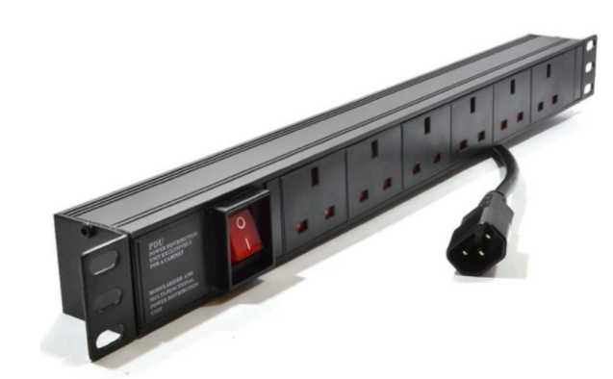

Description:

The LMS Power PDU-6WS-H-SP-1U-IEC is a high-quality surge protected, horizontally mounted PDU (Power Distribution Unit) that simply fits within the universal mounting brackets of data, telecom and server cabinets.
Providing piece-of-mind of integral electrical surge protection against common power surges and electrical spikes to devices including Ethernet Switches, Servers, UPS, NAS and of course cabinet accessories including cooling fan trays.
Robust, alloy design complete with rackmount brackets fitted, high-quality Neon Switch and of course UK output sockets together with a high quality, BSI-fitted
13 Amp UK plug.

Key Features:
Standard UK 3-Pin power outlets for your appliances
Built-in surge protection for critical device protection
1U horizontally mounted attaches to internal profiles
Neon On/Off Rocker switch to prevent accidental turn off
Backed up by LMS Power's exclusive 3-year warranty

Product Code:
Part Number: PDU-6WS-H-SP-1U-IEC
EAN: 8400800020499
Weight: 1.2Kg approx

Technical Specifications:
Warranty LMS Data 3-Year Warranty
Chassis 1U horizontally PDU with mounting brackets
Output Sockets 6 UK 3-PIN Sockets
Power Input Fitted UK 3PIN BSI Plug 13 Amp
Flex Length 1.8 metres (approx)
Power Control On/Off Rocker Switch (illuminated)
Power Rating 4000 Watts (approx) Surge Protected

Supplied With:
PDU-6WS-H-SP-1U-IEC 6 Way Horizontal PDU
Cabinet brackets (Fitted
* Specifications and product design are subject to change. E&OE.

Looking for highperformance power distribution for your heavily loaded systems? The newly developed LMS Data 13A heavy-duty horizontal PDU using the IEC-14 plug input connector which is ideal for many device requirements including server, network and other industrial-type equipment functions such as broadcast and HVAC applications. Combining a fully certified IEC-14 plug input combined with a compatible heavy load power flex means you can be assured this LMS Data PDU can work without problems, 24/7. Furthermore, incorporated onto the horizontal form-factor are industry standard UK sockets, ideal for data, telco and broadcast equipment with the added benefit of integral electrical surge protection. Robust in design, with an integral neon illuminated rocker switch for assured functionality, the LMS Data PDU is designed to deliver maximum electrical power today and tomorrow.

specifications:
Horizontal Power Distribution Unit (PDU)
Certified IEC-14 power input plug
Compatible, heavy-load power cable
6x UK power sockets
Robust, black aluminium design for industrial use
Neon on/off power switch for assured control
Maximum power rating - 4000W
2.0 metre (approx.) power cordage
Ideal for data, telecom, broadcast and HVAC applications

